RICHFIELD TOWNSHIP LUCAS COUNTY, OHIO
BOARD OF RICHFIELD TOWNSHIP TRUSTEES REGULAR MEETING MINUTES

April 6, 2026

The regular meeting of the Richfield Township Trustees was called to order by Andrew Bick at 7:00 p.m. at the Richfield Township Fire Department at 11450 Sylvania Avenue, Berkey, Ohio. All present were asked to rise for the Pledge of Allegiance.
ROLL CALL: Chairman Andrew Bick – present
Co-Chairman Vicky Loeffler-Bernheisel – present Kim Ronau – present

ADMINISTRATIVE REPORTS:

The clerk provided copies of the minutes from the March 16, 2026 and April 1, 2026 special meeting, current Cash Summary Report, Revenue Report, April Bank Reconciliation and Pending Warrants Report.

READING AND APPROVAL OF MINUTES:

Kim Ronau made a motion to approve the March 16, 2026 and April 1, 2026 minutes as presented. Vicky Loeffler seconded the motion. Roll call: all voted yes. Motion approved.

PRESENTATION OF THE BILLS:

The attached listings of warrants (14500– 145) were presented for approval:

Vicky Loeffler made a motion to approve payment of the attached listing of invoices and the corresponding pending warrants. Kim Ronau seconded the motion. Roll call: all voted yes. Motion approved.

PUBLIC COMMENTS:

Brandon Elliott (VP from Falcon Forge AI) gave a presentation regarding mandated Cybersecurity under HB 96. HB 96 outlines requirements for townships related to cybersecurity training and audit readiness.

Falcon Forge AI has

Built a dashboard and scoring system based on national standards incorporated in the law.

Conducted gap analyses for multiple townships (Springfield, Swanton, Spencer, Freedom, etc.).

Developed timelines and task lists targeting completion by June 1, ahead of the July 1 deadline.

Services & Costs:

Training: Cybersecurity training which is mandatory by the State of Ohio, Training must be started by July 1, 2026, all township employees will need to be trained.

Falcon Forge AI is an Ohio approved Cybersecurity training organization.

Training costs can be reimbursed, making training net zero cost to the township.

Non-reimbursable services:

Gap analysis: $1,000

Written compliance evidence playbooks and dashboard: $1,500

Total: $2,500 (not reimbursable).

Currently the township has GoDaddy high security which monitors township email.

The township has $250,000 in cyber liability coverage through Hylant Insurance, increased from $25,000 then $50,000 over recent years.

Trustees will review all information.

Statement – Firefighter Jen Wiley

Firefighter Jen Wiley (approx. eight years of service) addressed the Board to describe the department’s heavy reliance on low-paid volunteers, significant equipment and staffing shortages (expired hose and PPE, aging SCBAs and radios, limited in-town EMTs, and delayed response times when volunteers must drive in), and to emphasize that even if Richfield’s fire department were closed the township would still be legally required to provide fire protection through likely more costly outside contracts. She asked residents to support the department—both at the ballot box and on social media—and to recognize the extensive community service, training, and fundraising efforts undertaken by the volunteers and part-time staff.

Statement – Firefighter Jim Crooks

Firefighter Jim Crooks (over 40 years of service, 18 years full time, now a volunteer) spoke on behalf of the Firefighters’ Association, reporting that the Association voted not to publicly support the proposed 1.75 mill fire levy on the May ballot. He stated the levy is insufficient to meet the department’s actual needs— “not even a band‑aid”—and expressed concern that, if it passes, it could make it more difficult to obtain a larger, adequate levy in the near future.

Fire Levy Discussion (1.75 Mills)

The Board and attendees discussed the background and implications of the 1.75-mill fire levy.

Trustees explained that the 1.75 mill levy was calculated only to close the operating deficit, not to fund long-term capital needs: former Chief Pete estimated annual operating costs at $440,000 versus current revenue of $380,000, and, based on updated property values, the levy is projected to raise about $129,000/year, covering the ~$60,000 shortfall and leaving roughly $50,000–$60,000/year for equipment through late 2026–2027 at current service levels.

They noted that a past equipment reserve (funded at about $20,000/year) has been depleted by rising repair costs and aging equipment. The department relies on grants and used equipment rather than “Cadillac” purchases, and that while the Firefighters’ Association opposes the levy as too small—preferring a larger package closer to 10–12 effective mills (including the existing 6 mills) as recommended by former Chief Scarborough—the Board is concerned higher new millage is unlikely to pass following large property tax increases.

Former Chief Scarborough, who called the 1.75 mills a “band-aid,” requested the levy be pulled, but the Board of Elections advised it was too late to remove it from the ballot (though the Board could still declare it null and void); trustees also discussed that contracting with Springfield or Sylvania Township for 24/7 coverage might ultimately cost more, reduce local control, lengthen response times if crews are not based in Richfield, and could make re-establishing a local department difficult or impossible, despite a recent township survey showing strong resident support for keeping the township “as it is” and high support for the fire department.

FIRE:

Ryan Sedlock was introduced as the Interim Fire Chief following the resignation of Chief Pete Scarborough.

Interim Fire Chief Ryan Sedlock (former Sylvania Fire Lieutenant with extensive EMS and fire experience, including work with Dr. Boggs and the Medical Response Group) thanked former Chief Scarborough, the trustees, and the department for giving him a second chance in the fire service, praised the skill and dedication of Richfield’s firefighters and paramedics (noting that Richfield often cancels Sylvania when fully staffed), and outlined an operational vision that includes exploring a 3,500-gallon tanker with pump to replace an older engine, a mini-pumper for off-road/field access, and lease options for apparatus to ease capital costs. He invited residents to visit the station and participate in community events, asked all department members present to stand and be recognized.

ZONING:

Introduction of new Zoning Inspector Zach Mikolajczyk.

Background: Currently employed by Metroparks Toledo and has prior experience with Lucas County Engineers.

FISCAL OFFICER:

Steering Committee Grant: The township received $50,000 from the steering committee grant via direct deposit on April 1.

Letter received from the Ohio Department of Commerce regarding liquor permit renewals within the township.

Vicky Loeffler-Bernheisel made a motion to approve the continuation of the liquor permit renewals in Richfield Township. Kim Ronau seconded the motion. Roll call: all voted yes. Motion approved.
ODOT Road Salt Contract 2026: The Ohio Department of Transportation (ODOT) submitted a resolution for participation in the 2026 road salt contract. Dan Walters (maintenance) recommended ordering 50 tons due to substantial remaining inventory.

See attached Resolution Authorizing Participation in The ODOT Road Salt Contracts in 2026.

Andrew Bick made a motion to approve the Resolution Authorizing Participation in the ODOT Road Salt Contract in 2026. Vicky Loeffler-Bernheisel seconded the motion. Roll call: all voted yes. Resolution approved.

Lucas County Sheriff – Patrol Report
For the recent two-week period:
- 15.5 hours of patrol time in the township.
- 4 warnings issued.
- 1 citation issued.
- 5 traffic stops.
- 1 motorist assist.

Timesheets were distributed to Trustees for their review.

TRUSTEE REPORTS:

Trustee Loeffler-Bernheisel reported she attended a two‑day grant management class. Recommended budgeting to send additional personnel for grant writing and management training. Aiming to build internal capacity rather than relying solely on outside grant writers, except for very large fire/EMS capital grants where specialists are still advantageous.

Presented a new form for “Injury and Illness Reporting” for BWC purposes. Employees will be required to complete along with the required form from BWC.

Vicky Loeffler made a motion to approve and adopt the Richfield Township Injury and Illness form. Andrew Bick seconded the motion. Roll call: all voted yes. Motion approved.

A revised job description for the Fire Chief will be prepared and presented at the next meeting.

A simplified job description for a Township Administrator was discussed.
- The administrator would have no voting rights and would not make policy decisions, but would:
- Implement and administer Board resolutions.
- Serve as a liaison between trustees and departments.
- Recommend operational improvements and policies for Board consideration.

Discussion on cemetery grave digging and the need for a backup plan in the event our current contractor is not available. A proposal from another contractor ($600 per grave) was discussed as a potential backup. The Board will seek additional quotes and providers for back-up.

Crossroad’s project has been extended through the end of August, 2026.

Currently working on increasing the mileage rate for Medicount, will email the necessary documentation to support this change.

Trustee Ronau reported that she is working with Assistant Prosecutor John Borell to locate the deed for the town hall property. Mr. Borell has not yet been able to locate the document and is continuing his search. A clear deed is needed before deciding to sell, rehabilitate, or demolish the building.

Trustee Bick reported that Dan Walters (maintenance) cleaned and improved the appearance of the Gibbs Road bridge, including the bridge railing and adjacent walls.

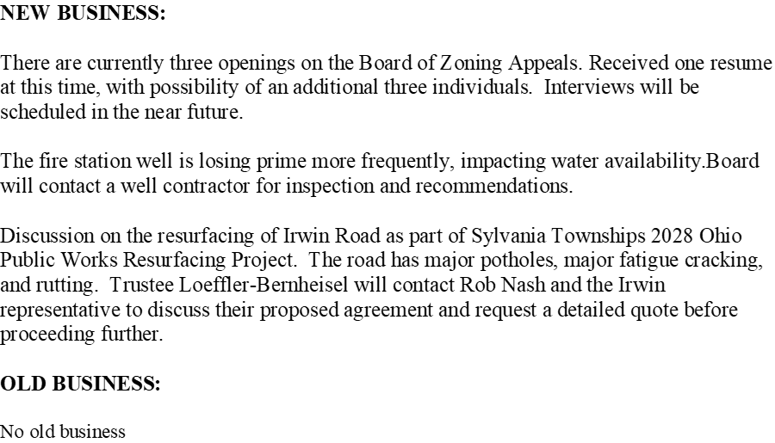

PUBLIC NOTICE:

The following information can be viewed on the Richfield Township website at: www.richfieldtwp.com.

1. Trustee minutes
2. Zoning minutes
3. Zoning including: fees, applications, complaint forms, and the zoning book.
4. Meeting dates and times
5. Contact information for Trustees, Zoning Board and Board of Zoning Appeals.
6. Wolfinger Cemetery information including cemetery fees, rules & regulations.
7. Fire and Rescue
8. Roads and Maintenance
9. Rubbish Contractor information for garbage pickup
10. Community Links.

There being no further business Kim Ronau made a motion to adjourn at 8:35 p.m., which was seconded by Vicky Loeffler-Bernheisel: Roll call: Ronau-yes, Loeffler-Bernheisel – yes, Bick – absent. Motion approved.

_____________________________ ______________________________
Richfield Township Fiscal Officer

______________________________

______________________________

